Code Review: I2305059
Reviewer: James Wood
Date: May 15th, 2023
Bugs
Preventative Action/Safety
- When setting the ReadOnly/Hidden fields of a column(including the Override properties), use our built-in extension methods. sxSetReadOnlyOverride, for example. These take care of the busy work of ensuring the column tag is actually an sxTag.
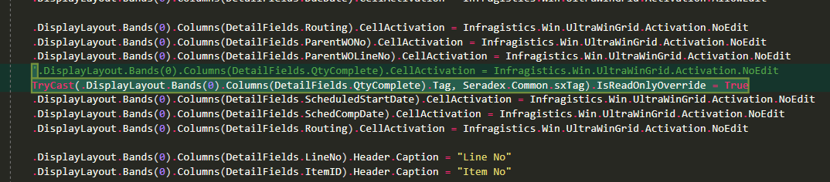
- Nit: After discussion, this has been logged under another ticket. It looks like other columns are also set to NoEdit. I assume having these be modifiable by the user is not a big deal as they don’t affect any updates or inserts or other functionality. However, we also do not want to confuse any easily confused people. I recommend updating any columns specified as NoEdit, to the same ReadOnlyOverride = True.
I assume that any column marked as NoEdit was intended to be permanently read only.
Design/Architecture (Duplication, appropriate project, namespaces, maintainability)
Data Model(Naming, good design, needs index?)
Performance (Minimize DB hits, excessive loops, queries, scalable)
UI(Alignment, naming, standardization)
Error Handling(Behind events, appropriate parameter checking)
Cleanup (Dispose code, remove handlers, large data objects)
Readability (Well-named variables, methods, clear algorithm, is it understandable)
Comments (Useful, explains why rather than how)
Message Boxes (Grammar, spelling, captions, appropriate icons)
Ticket Management(Release Branch?, Testing Notes)
Extras
- When using TryCast(), directly interacting with the casted object renders the call pointless, as in:
TryCast(Animal, Human).WriteNovel()
The TryCast is not doing all that much here. The purpose of TryCast() is so that it doesn’t fail when the cast is not possible. If the cast fails, what happens instead is that Nothing is returned. When using it in the above manner, if the Animal object is actually of type Koala, then the cast will fail and default to Nothing, but calling .WriteNovel() on Nothing will obviously not work. If a direct call after the cast is made, then DirectCast might as well be used, as that will fail if the cast fails.
Note, I am very guilty of using it this way.

